Business Requirement Document: Medico Pvt. Ltd.



# Medico Private Limited

# Business Requirements Document (BRD)



*Medico Private limited*

*February 2022*

## 1 Introduction

### **1.1 Project Summary**

#### **1.1.1 Objectives**

* Enhancing client’s business of selling medical devices by transforming the data into meaningful reporting
* Making dashboards for client’s internal teams to understand the business better
* Various department members will be able to see the progress & track their performance from these dashboards from time to time and make changes in their processes accordingly
* To help the business owner take decisions based on data backed analysis to deliver

#### **1.1.2 Background**

A central data repository is necessary for simplifying the data analytical process for the client. Client should be able to search through all the data and retrieve it as and when required. Data analytical solutions that will be provided to the client will help in making the right decisions for the business and understand how to grow the business by improving it in different areas.

#### **1.1.3 Business Drivers**

* Client is looking for having all the data in one place
* Various internal teams within the client organization are going to be the end users of the dashboards
* Client is responsible for managing all the data from various sources and dumping them at one place for further processing

### **1.2 Project Scope**

The scope of the project is to design and develop dashboards for ERP data, pipeline and opportunity processes. Client will be able to use the dashboard views for interpreting the various trends of sales and other quantitative measures available from the data and therefore make the changes in the organization accordingly. The Admin of these dashboards will help the client in understanding the changes made in data based on the requirements specified.

#### **1.2.1 Scope Functionality**

* Opportunities
  + - Expected Amount
    - Active Opportunities
    - Conversion Rate
    - Win Rate
    - Expected Amount by Opportunity Type
    - Expected Amount by Account Name
    - Expected Amount by Opportunity Owner
    - Expected Amount by Industry
    - Expected Amount by Stage
* Pipeline
  + - Sales forecast amount
    - Amount by Opportunity Stage
    - Open opportunities by Stage
    - Pipeline Details
* ERP data
  + - Total Sales
    - Total Profit
    - Total Volume
    - Sales per Customer
    - Profit by State
    - YTD Sales by State
    - Sales by Product

### **1.3 User Roles**

| **Role** | **Description** |
| --- | --- |
| **Client** | * Client will be able to search for products’ overview and their sales performance * View leads converted to sales * View opportunities converted to sales * View regions having more/less sales * View status of a lead * Check the stage of opportunity |
| **Admin/ Owner** | * Develop dashboards * Manage dashboards * Store & Manage data * Manage roles and permissions |

### **1.4 System Perspective**

#### **1.4.1 Assumptions**

* Data is cleaned and transformed
* Data is historical
* Admin will manage the data access control
* Erroneous records are not considered for calculations
* Price of the products will be in USD.

#### **1.4.2 Constraints**

* Trainings
* Additional dashboards or changes in features & functionalities described in document may require changing the time estimation of the project development
* Timeline for enterprise platform updates will impact development & testing, unless the environment is a sandbox

#### **Data**

* CRM data is loaded from snowflake warehouse using Data_Analyst Role with Operations Schema
* Data extract is made within Tableau once the data is connected through the snowflake ODBC connector

#### **1.5 Wireframing**

* Based on the KPIs identified for the respective dashboards, a separate wireframe has been developed using a wireframing tool called Figma
* Figma is a free online UI tool used to create, collaborate and prototype various custom wireframes
* Multiple people can edit and view the same file simultaneously while it gets synchronised in real time

## 2 Business Process Overview

* Client gets developed dashboards
* Search for the desired KPI in the dashboard by navigating various categories
* View product performance
* Get product details with respect to opportunities & leads
* Proceed for filtering region wise performance of the products
* Track lead status and opportunity stages
* End of review process.

**2.1 Architecture**

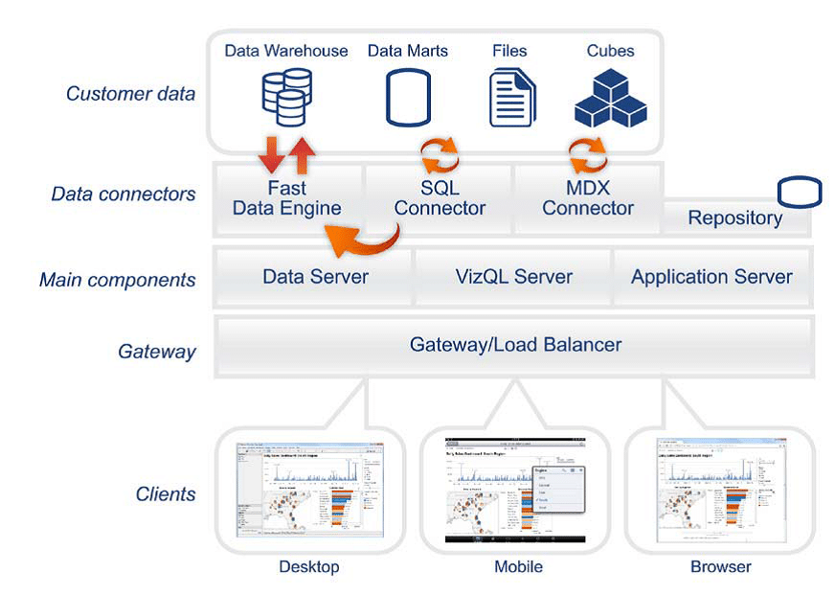

**Fig: Tableau Architecture**

Tableau can connect to multiple data sources remotely, be it an excel file, a web application or a database. We connect tableau to snowflake using Snowflake provided ODBC connector from the “help” connection within the snowflake instance. Data Engine stores the tableau data extract which is pooled from various data sources. Data Engine responses to any visualization that has been created using the tableau data extract.

The gateway, using the application server for authentication process will forward the login request to the server. When the authenticity is verified, it returns with the database we have requested access for along with the type of schema & warehouse based on the type of data source we are trying to connect.

**3 Business Requirements**

**3.1 Functional Requirements**

| KPI | Description |
| --- | --- |
| Expected Amount | The amount that we get if the opportunity gets converted to sales. |
| Active Opportunities | Active Opportunities are closed/won opportunities between the booked start date and the end date. |
| Conversion Rate | It is the percentage of leads that convert to opportunities. |
| Win Rate | The Opportunities won, divided by the total number of opportunities created. |
| Expected Amount by Opportunity Type | The anticipated amount by opportunity type i.e. cross sell, up sell, new and existing. |
| Opportunities by Account Name | The opportunities by company names. |
| Opportunities by Opportunity Owner | The sales representative who has been assigned primary ownership for an opportunity. |
| Opportunities by Industry | It shows the opportunities industry wise. |
|  |  |
| Sales Forecast Amount | Forecasted sales amount in $ at each stage |
| Amount by Opportunity Stage | Expected Amount by each stage based on country, manager, & opportunity owner |
| Open Opportunities by stage | Number of active opportunities at each stage |
| Pipeline details | Amount based on stage, account name & close date |
| Total Sales | Total Sales Amount in $ |
| Total Profit | Total Profit earned in the period |
| Total Volume | Total number of units sold |
| Total Sales per Customer | Total Sales Amount from the Customer |
| Profit by State | Profit gained from each state in US |
| YTD Sales by State | Year to Date Sales amount by each state |
| Sales by Product | Sales Amount In $ by each product |

**3.2 Non-Functional Requirements**

| ID | Description |
| --- | --- |
| NFR-001 | Scalability: Tableau shall accommodate more than 300 MB of data at a time |
| NFR-002 | Speed: Dashboards should not take more than 30 seconds to load in good speed of internet |